# **Create authentication service that returns JWT**

SecurityConfig.java

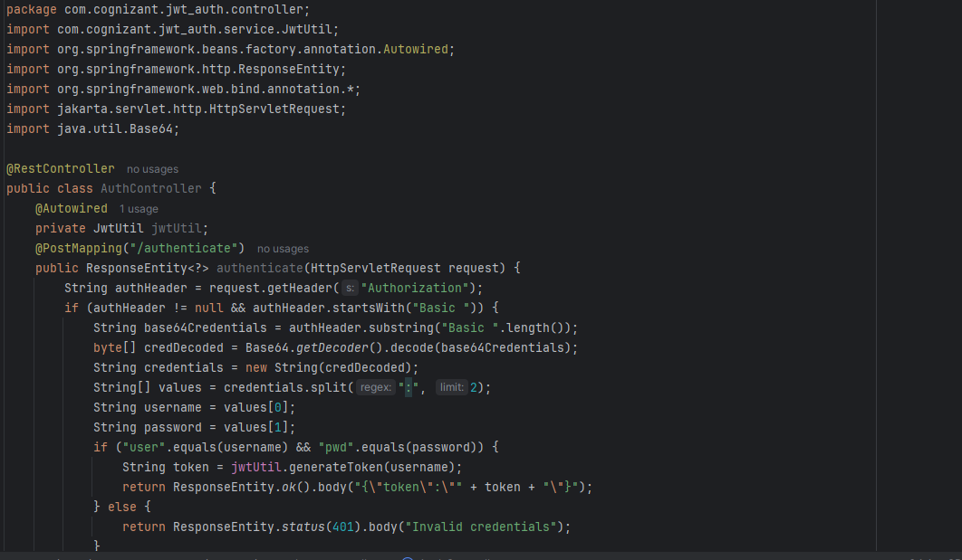

AuthController.java

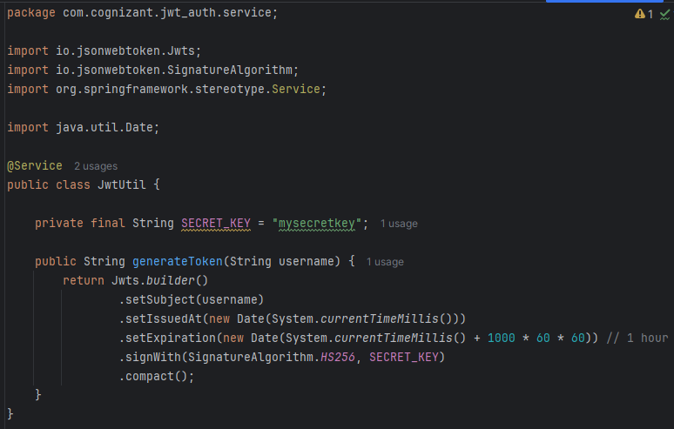

JwtUtil.java

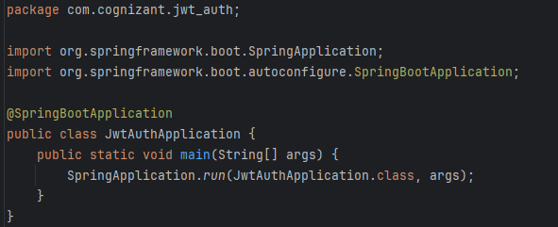

Output:

